Routes for Ms. Dinner and Mr. Thomas Journey in Costa Rica
Liberia, Gulf of Papagayo, Las Catalinas, Monteverde, Manuel Antonio, Arenal and Liberia

Liberia’s International Airport – Hotel Mangroove at Playa Panamá
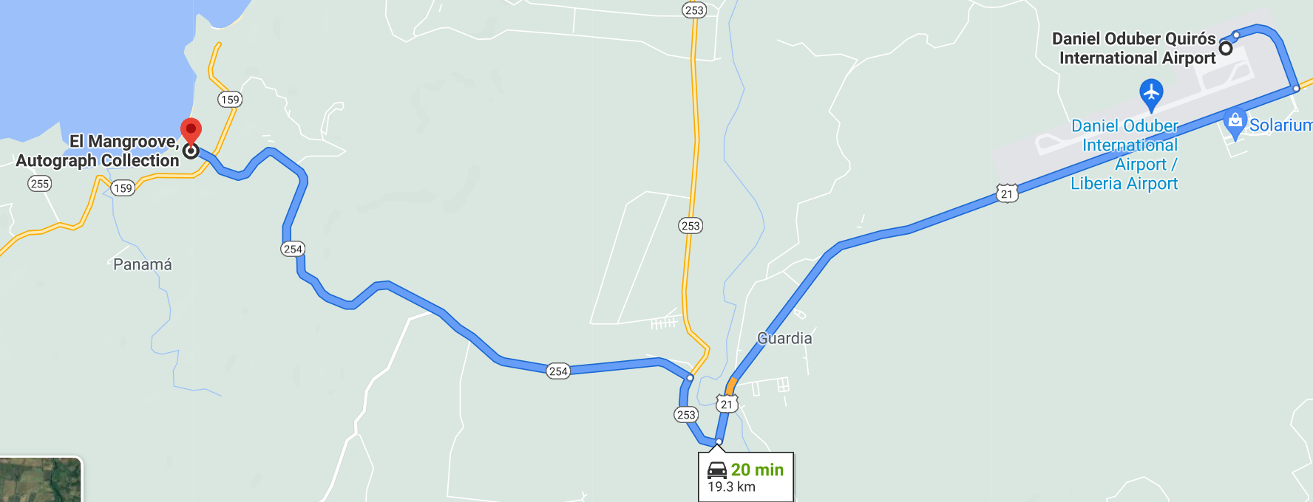

Hotel Mangroove – Bosque del Mar
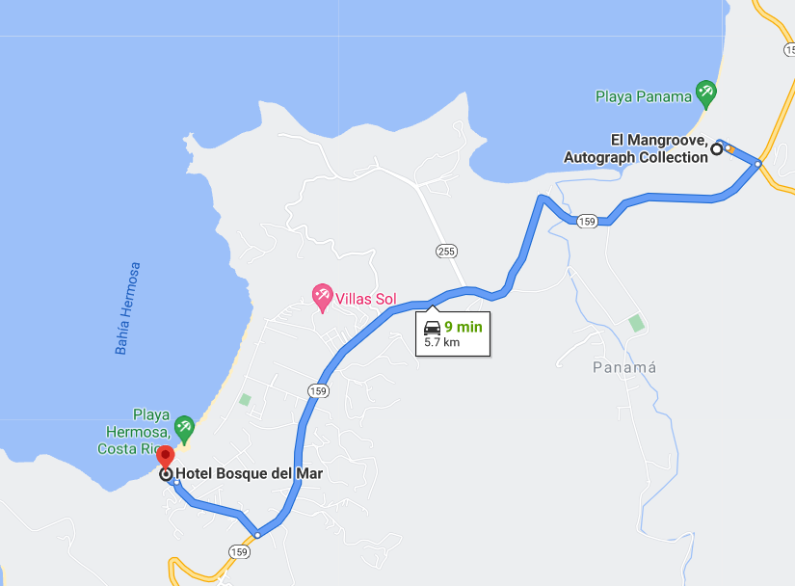

Bosque del Mar – Andaz
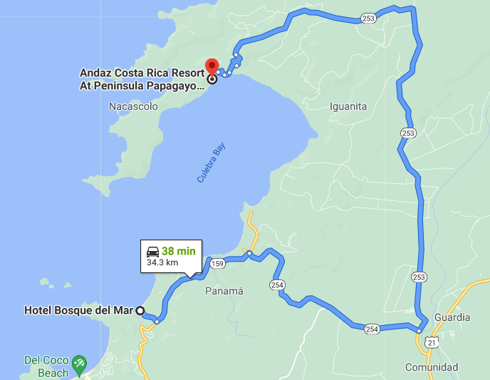

Andaz Hotel – Las Catalinas
This road is narrow and winding, the recommendation is to drive slowly. The communities they will pass are:

Comunidad
Sardinal
Artola
Nuevo Colón
Potrero

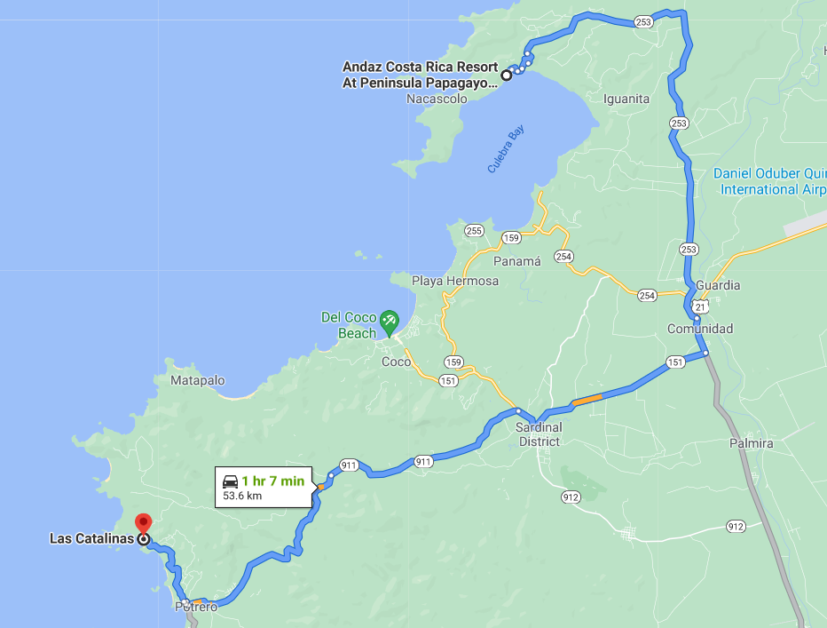

Las Catalinas – Monteverde
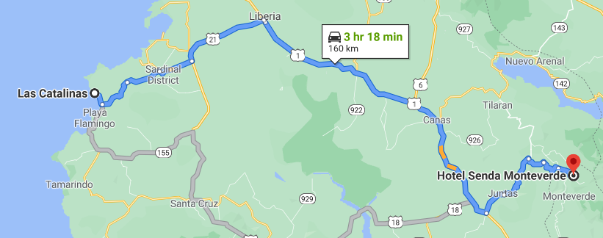

Monteverde – Manuel Antonio
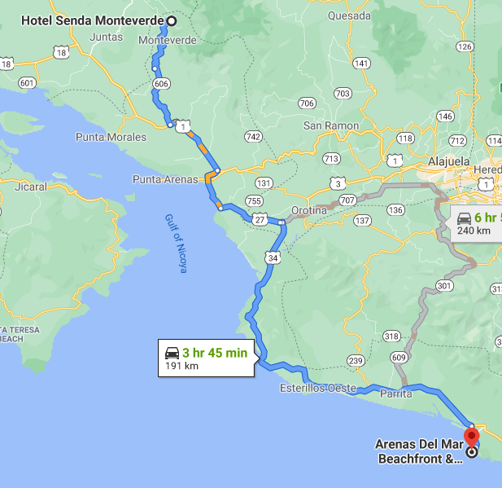

Manuel Antonio – Arenal
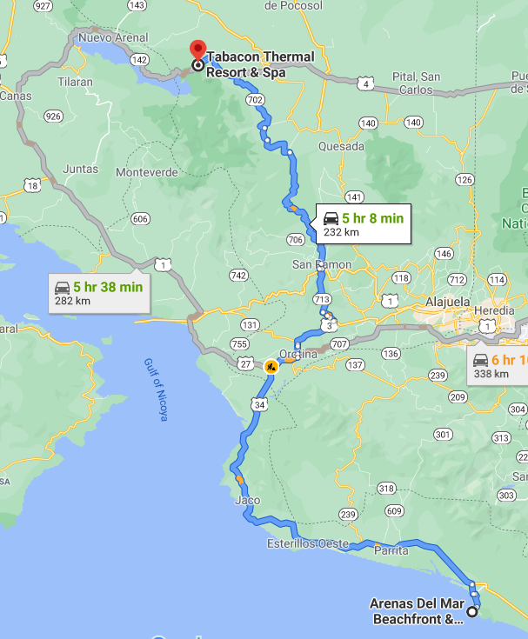

Arenal - Liberia’s International Airport
